1. Alarm should sound in one manner if temp is above 60C

CODE:

Void setup ()

{

Serial. Begin (9600);

Pin Mode (5, OUTPUT);

}

Void loop ()

{

Int data=analog Read (A0);

Double n=data/1024;

Double volt=n\*6;

Double off=volt-0.6;

double temperature=off\*100;

Serial.print ("Temperature data :");

Serial.println (temperature);

Tone (5,100);

delay (1000);

tone (5,200);

delay(1000);

}

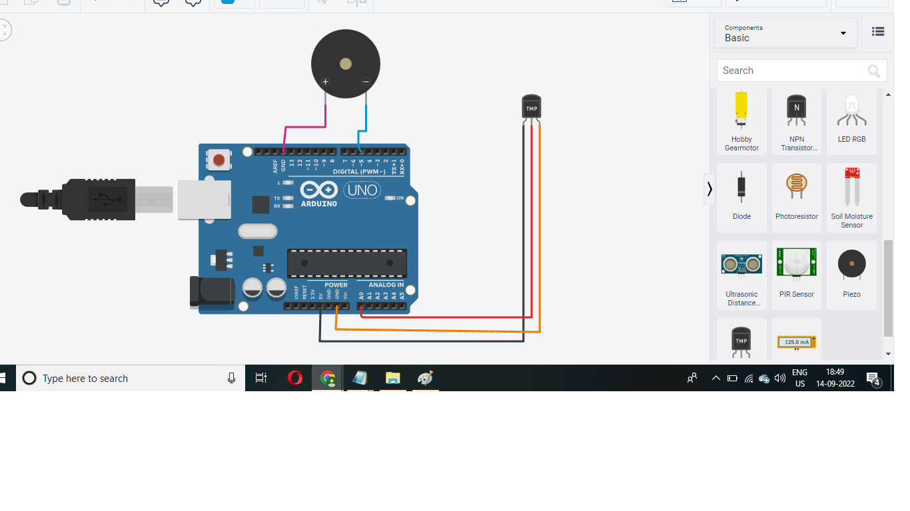

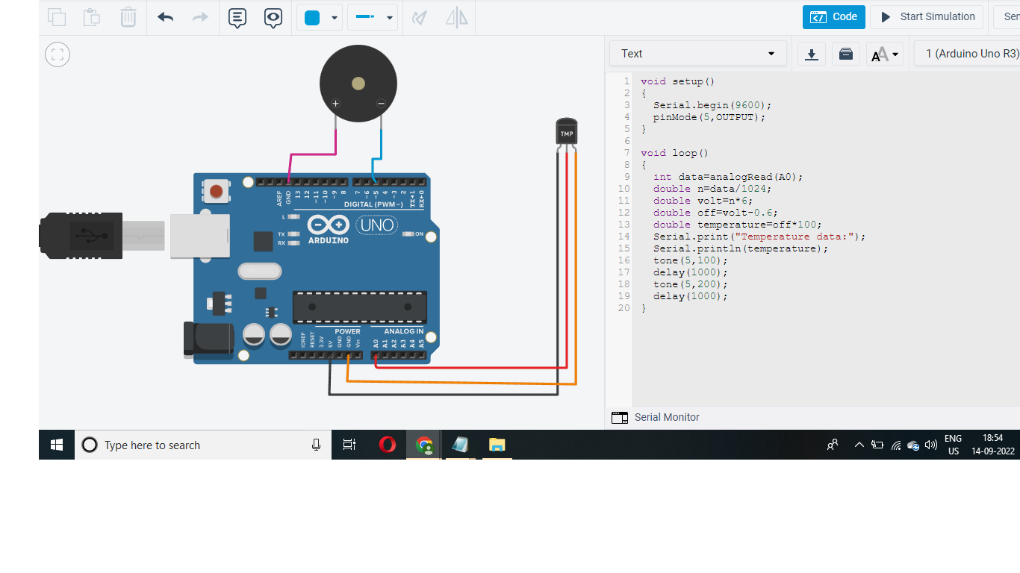

2. Alarm should sound with another frequency if motion is detected in PIR sensor

Void setup ()

{

Pin Mode (2, INPUT);

PinMode(13, OUTPUT);

}

Void loop ()

{

if (digitalRead(2)==HIGH)

{

digitalWrite(13, HIGH);

}

else

{

digitalWrite (13, LOW);

}

Delay (10); // Wait for 1000 millisecond(s)

}

